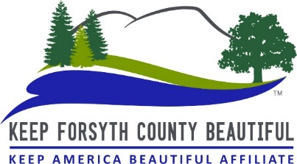
Adopt-A-Road Status Report Form
Please turn in this form within 3 days of pickup

Please pick up any advertising signs that are on the right of way. Also, please be
sure to clean the entire adopted portion of your road, from cross street to cross
street. (This is slightly past your Adopt-a-Road signs on each end.) Thank you!

Date: Click here to enter text

Adopt-A-Road Group/Person’s Name: Click here to enter text

Contact Name: Click here to enter name

Contact’s Phone Number: Click here to enter phone number

County Road Name: Click here to add road name

Number of Bags filled: Enter number here

Number of Participants: Enter number here

Time spent on clean up ________A.M./P.M. to ________A.M./P.M.

Does the trash need to be picked up? Enter either “YES” OR “NO” here

If we need to pick up the trash please let us know exactly where it was left:
Fill in location here_____________________________________________________

Revised 7/27/2023

