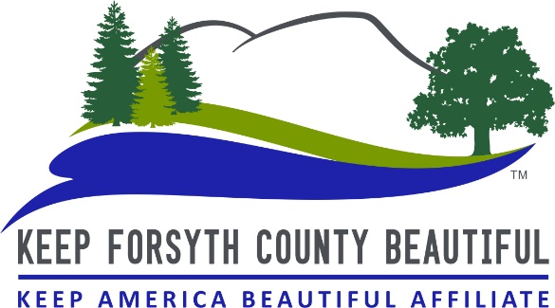

STORM DRAIN MARKING STATUS REPORT

Following each Storm Drain Marking project, please return this completed form to:
Keep Forsyth County Beautiful

1950 Sharon Road
Cumming, GA 30041
Office 770-205-4573
kfcb@forsythco.com

Storm Drain Marking Group Name: Click here to enter name
Contact Name: Click here to enter name
Contact’s Phone Number: Click here to enter phone number
Date of Marking: Click here to enter date
Subdivision/Park/School/Area Name: Click here to enter name
Number of Drains Marked: Enter number here
Hours Spent Marking: Enter no. of hours here
Number of Youth Participants: Enter number here
Number of Adult Participants: Enter number here
Are there more drains that still need marking? Enter either “YES” OR “NO” here
If yes, how many drains still need marking? Enter number here

*** Please turn in this form within 3 days of completing
your Storm Drain Marking project ***
THANK YOU!
10/2018

