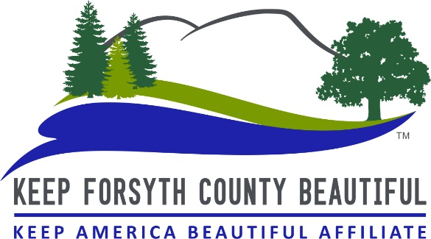
Storm Drain Marking Program Contract

Keep Forsyth County Beautiful and ______________________ (your name/organization) recognize the need and desirability of keeping harmful contaminants out of our storm drains. Thus, the Storm Drain Marking program has been established for civic groups, non-profit organizations, and other interested parties to contribute toward the effort of marking storm drains.
___________________ is aware of the potentially hazardous work which is to be performed and agrees to abide by the Storm Drain Marking Safety Rules and Regulations. And also understands that while Keep Forsyth County Beautiful agrees to cooperate in the development of the program, they cannot assume any liability with respect thereto. Therefore, Keep Forsyth County Beautiful recognizes:

Name of Organization (if applicable): ____________________
Name of Contact person: ______________________________
E-mail address: ______________________________________
Contact person best contact number: _________________

The area where we will be marking storm drains is:
Name of subdivision/neighborhood/park/school________________________________________
Address: ________________________________________________________________________________
City________________________ State_______ Zipcode_________________
Notes regarding location: ________________________________________________________________________________
________________________________________________________________________________

Signature ________________________________________________

Printed Name ____________________________________________

Today’s Date _____________________________________________
10/2018

